OfficeGrader Project Documentation

# Description

The OfficeGrader Project Moodle plugin automates

1. Submitting student assignment documents to an OfficeGrader grading server, and
2. Distributing grades and marked-up graded documents to the students.

The plugin also automatically updates grades in the Moodle gradebook.

Without this plugin, when students submit documents for grading, the instructor must manually submit them to an OfficeGrader grading server, or if a grading server is not available, the instructor must run the appropriate OfficeGrader grading program. After the documents have been graded, the instructor must enter the grades into the Moodle gradebook and distribute the marked-up graded documents to the students.

The OfficeGrader Project plugin automates all this, thus removing the need for instructor intervention. The instructor only needs to create the OfficeGrader Projects in Moodle, and the plugin takes care of handling and grading student submissions.

# Requirements

* Moodle version 2.7 or greater
* A folder the web server has permission to read from and write to (moodledata by default)

Quickstart Installation Instructions

1. Copy the "og" folder and its contents to the "mod" folder of your Moodle installation
2. Log in as admin and go to Administration > Site administration > Notifications
3. Verify the status of the OfficeGrader plugin is "To be installed"
4. Click "Upgrade Moodle database now" at the bottom of the page
5. Leave the Office Grader FTP path the moodledata folder (the default) [OR if you prefer, create a user and new ftp path OR use existing user and create ftp path. Add user to the www-data (or your web server’s) group, and give write privileges to the folder to the web server.]
6. If not already set, edit Moodle cron schedule to execute every minute (or your preference, we recommend one minute.)

Detailed Installation Instructions

If your Moodle installation uses a theme other than the default, the screenshots in the steps below may show different formatting than what you will see on your screen. The screenshots below use the Clean theme.

1. Locate the “mod” folder of your Moodle installation. On a Windows computer with WAMP installed, this folder may be at C:\wamp\www\moodle\mod. On a computer running Linux, the “mod” folder may be at /var/www/html/moodle/mod. The exact location may differ, depending on where Moodle was installed.
2. Copy the “og” folder and its contents to the “mod” folder you located in step 1.
3. Open a web browser and navigate to your Moodle site.
4. Log in with an administrator account.
5. 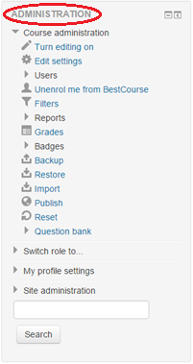Locate the “Administration” block. The items in this block may be different from the screenshot depending on the page you are viewing.
6. 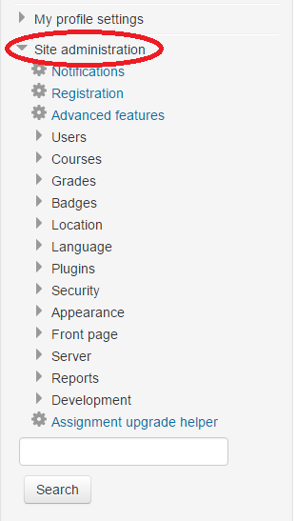Select “Site administration”
7. 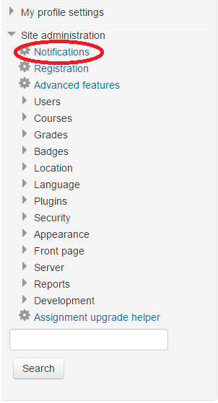Select “Notifications”
8. 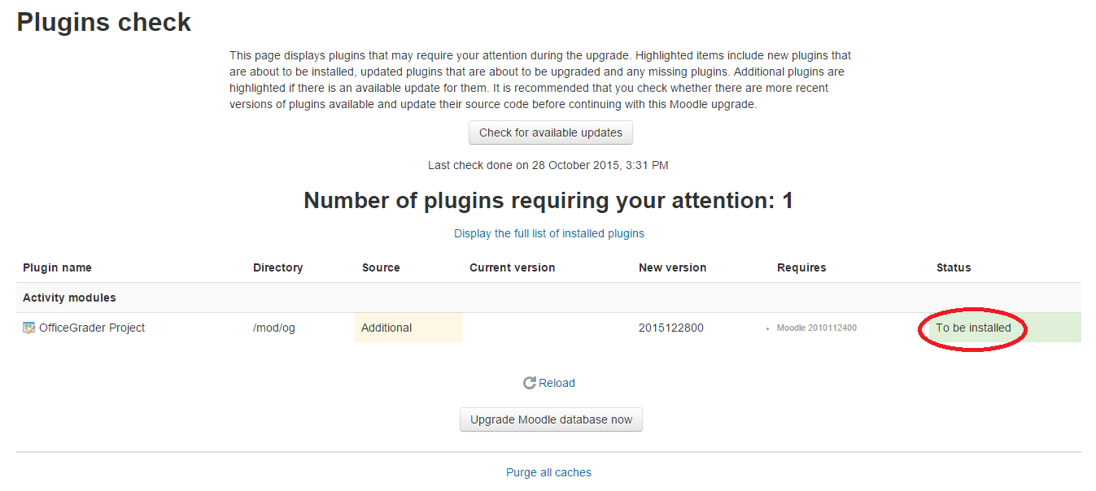Verify the status of the plugin is “To be installed”. See the Troubleshooting section of this document if you have any problems.
9. 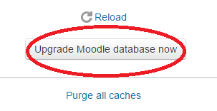Click “Upgrade Moodle database now”. There may be a delay before the next page appears.
10. 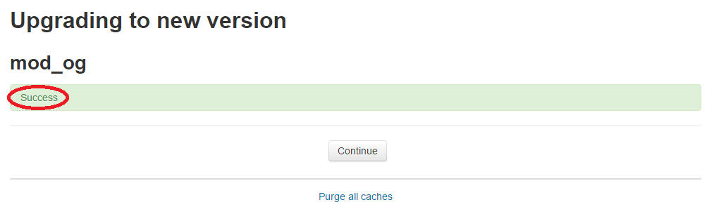Verify the installation was successful.
11. 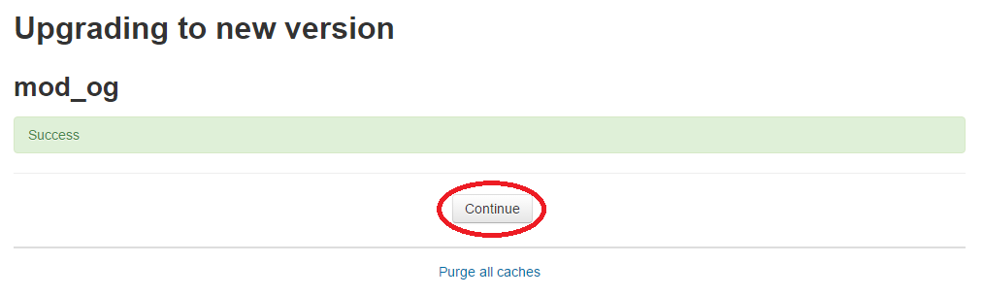Click “Continue”
12. 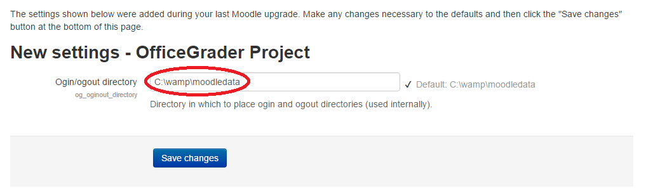Select a folder the plugin can use to read and create the files it needs to send to and from the OfficeGrader grading server. Use the default folder if you have no preferences. (Your default folder may be different from the one shown here. It can be any folder an FTP account may access, that is owned by the web server’s group, and has write privileges.)
13. 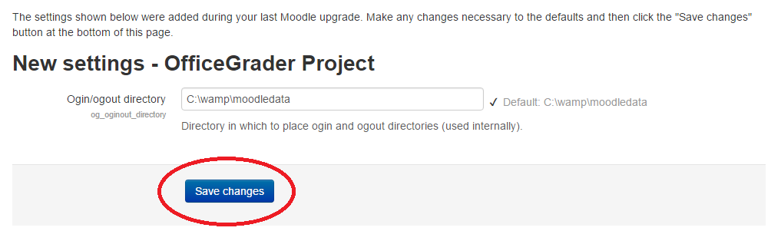Click “Save changes”

You should now be redirected to the plugins overview page, and the OfficeGrader Project plugin should be successfully installed. See the Troubleshooting section of this document if you have any problems.

# FTP User

To FTP files to the moodledata folder, you can choose an existing user, OR create and set up an oguser user account. To create a new user, use commands similar to the example below (Ubuntu/Debian.) Open a terminal, copy and paste these lines, and press Enter after each line:

sudo useradd -g www-data oguser

sudo mkdir /home/oguser

sudo chmod -R 777 /home/oguser

# How Often to Check for New Submissions

You also need to verify that the Moodle cron script is set to run at reasonable intervals (once a minute is recommended). To edit cron settings on Debian/Ubuntu, enter the following command in a terminal window:

sudo crontab –u www-data -e

This will open an editor window in which you can edit the cron file. To run the Moodle cron script every minute, add this line (or edit the existing Moodle cron line), followed by an empty line:

*/1 * * * * /usr/bin/php /path/to/moodle/admin/cli/cron.php >/dev/null

See [http://docs.moodle.org/en/Cron](http://docs.moodle.org/en/Cron%20) for more information on setting up cron for Moodle.

# Usage

Follow these steps to add OfficeGrader Projects to a course.

1. Using a web browser, navigate to the desired course in your Moodle site.
2. Click “Add an activity or resource” in the desired section of the course.
3. Select “OfficeGrader Project” in the box that appears.
4. Click “Add”.
5. Fill in the fields as desired. For help, click the question mark icon beside the appropriate field. Fields with a red asterisk **\*** are required; all other fields are optional.
6. When finished, click “Save and return to course” to add the OfficeGrader project and redirect to the course, or click “Save and display” to add the OfficeGrader project and redirect to the newly added project.

# Troubleshooting

Problem: The admin notifications page does not show the OfficeGrader plugin (step 3 of the “Quick installation” section, or step 8 of the “Detailed installation instructions” section).

Solution: Make sure you copied the “og” folder and all its contents to the “mod” folder of your Moodle installation.

Problem: The Ogin/ogout directory settings page says “This value is not valid” when you click “Save changes”.

Solution: Enter a valid path to an existing folder. If you don’t know what to enter, just copy the default path (given beside the text input field).

Problem: The Ogin/ogout directory settings page says “The specified directory is not readable or writable” when you click “Save changes”.

Solution: Either change the permissions of the specified directory so the web server can read from and write to the folder, or choose a different folder. The default folder should work (the path is given beside the text input field).